*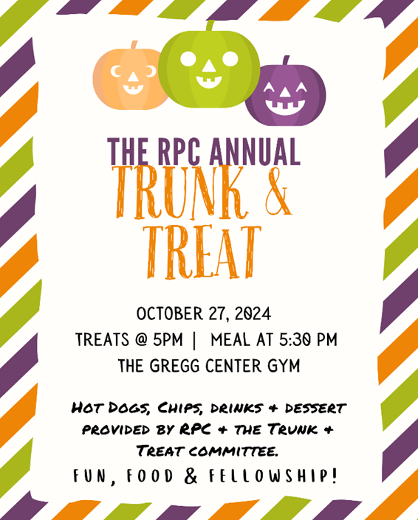*

*The Gregg Center will be open Oct. 21-Oct 24 Noon,*

*if you would like to come by & set up your table!*

*It will also be open after worship on the 27th until 4 pm,*

*if you want to wait until then.*

*Tables & coverings will be provided.*

*Come join us for an evening of fun, food & fellowship!*

**

*The Gregg Center will be open Oct. 21-Oct 24 Noon,*

*if you would like to come by & set up your table!*

*It will also be open after worship on the 27th until 4 pm,*

*if you want to wait until then.*

*Tables & coverings will be provided.*

*Come join us for an evening of fun, food & fellowship!*